Innovative Methods of Teaching

Abstract/ Purpose –The purpose of this paper is to evaluate the traditional methods of teaching as well as multimedia teaching and to suggest other useful teaching methods that can be attempted in imparting knowledge to the students. Basically teaching must include two major components sending and receiving information. Ultimately, a teacher tries his best to impart knowledge as the way he understood it. So, any communication methods that serve this purpose without destroying the objective could be considered as innovative methods of teaching. The use of innovative methods in educational institutions has the potential not only to improve education, but also to empower people, strengthen governance and galvanize the effort to achieve the human development goal for the country.

I.Introduction

Education is a light that shows the mankind the right direction to surge. The purpose of education is not just making a student literate but adds rationale thinking, knowledgeablity and self sufficiency. When there is a willingness to change, there is hope for progress in any field. Creativity can be developed and innovation benefits both students and teachers.

II.Importance of Education:
Islam attaches such great importance to knowledge and education. When the Qur'an began to be revealed, the first word of its first verse was 'Iqra' that is, read. Education is thus the starting point of every human activity. A scholar (alim) is accorded great respect in the hadith. According to a hadith the ink of the pen of a scholar is more precious than the blood of a martyr. The reason being that martyr is engaged in defense work while an alim (scholar) builds individuals and nations along positive lines. In this way he bestows a real life to the world.
“Education is the manifestation of perfection already in man” –
(Swami Vivekananda)
Education is a light that shows the mankind the right direction to surge. If education fails to inculcate self-discipline and commitment to achieve in the minds of student, it is not their fault. We have to convert education into a sport and learning process has to generate interest in the students and motivate them to stay back in the institution than to run away from it. Education should become a fun and thrill to them rather than burden and boredom. It is an integral part of their growth and helps them become good citizens.
Education is an engine for the growth and progress of any society. It not only imparts knowledge, skills and inculcates values, but is also responsible for building human capital which breeds, drives and sets technological innovation and economic growth. In today’s era, information and knowledge stand out as very important and critical input for growth and survival. Rather than looking at education simply as a means of achieving social upliftment, the society must view education also as an engine of advancement in an information era propelled by its wheels of knowledge and research leading to development.

III.Methodology
The traditional or innovative methods of teaching are critically examined, evaluated and some modifications in the delivery of knowledge is suggested. As such, the strengths and weaknesses of each teaching methodology are identified and probable modifications that can be included in traditional methods are suggested.

IV. Traditional Teaching Method – An evaluation
In the pre-technology education context, the teacher is the sender or the source, the educational material is the information or message, and the student is the receiver of the information. In terms of the delivery medium, the educator can deliver the message via the “chalk-and- talk” method and overhead projector (OHP) transparencies. This directed instruction model has its foundations embedded in the behavioral learning perspective (Skinner, 1938) and it is a popular technique, which has been used for decades as an educational strategy in all institutions of learning.
Basically, the teacher controls the instructional process, the content is delivered to the entire class and the teacher tends to emphasize factual knowledge. In other words, the teacher delivers the lecture content and the students listen to the lecture. Thus, the learning mode tends to be passive and the learners play little part in their learning process (Orlich et al.,1998). It has been found in most universities by many teachers and students that the conventional lecture approach in classroom is of limited effectiveness in both teaching and learning. In such a lecture students assume a purely passive role and their concentration fades off after 15-20 minutes.
Some limitations which may prevail in traditional teaching method are
 Teaching in classroom using chalk and talk is “one way flow” of information.
MESSAGE
SENDER RECIEVER

(TEACHER) (STUDENT)
MEDIUM

- Teachers often continuously talk for an hour without knowing students response and feedback.
- The material presented is only based on lecturer notes and textbooks.
- Teaching and learning are concentrated on “plug and play” method rather than practical aspects.
- The handwriting of the lecturer decides the fate of the subject.
- There is insufficient interaction with students in classroom.
- More emphasis has been given on theory without any practical and real life time situations.
- Learning from memorization but not understanding.
- Marks rather than result oriented.

V.INNOVATIVE TOOLS

(A)MULTIMEDIA LEARNING PROCESS
I hear and I forget.
I see and I believe.
I do and I understand. - Confucius
Multimedia, is the combination of various digital media types such as text, images, audio and video, into an integrated multi-sensory interactive application or presentation to convey information to an audience. Traditional educational approaches have resulted in a mismatch between what is taught to the students and what the industry needs. As such, many institutions are moving towards problembased learning as a solution to producing graduates who are creative; think critically and analytically, to solve problems. In this paper, we focus on using multimedia technology as an innovative teaching and learning strategy in a problem-based learning environment by giving the students a multimedia project to train them in this skill set.
Currently, many institutions are moving towards problem-based learning as a solution to producing graduates who are creative and can think critically, analytically, and solve problems. Since knowledge is no longer an end but a means to creating better problem solvers and encourage lifelong learning. Problem-based learning is becoming increasingly popular in educational institutions as a tool to address the inadequacies of traditional teaching. Since these traditional approaches do not encourage students to question what they have learnt or to associate with previously acquired knowledge (Teo & Wong, 2000), problem-based learning is seen as an innovative measure to encourage students to learn how to learn via real-life problems (Boud & Feletti, 1999).
The teacher uses multimedia to modify the contents of the material. It will help the teacher to represent in a more meaningful way, using different media elements. These media elements can be converted into digital form, modified and customized for the final presentation. By incorporating digital media elements into the project, the students are able to learn better since they use multiple sensory modalities, which would make them more motivated to pay more attention to the information presented and retain the information better.

Chart 1 - MULTMEDIA ELEMENTS
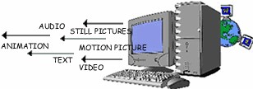

Creating multimedia projects is both challenging and exciting. Fortunately, there are many multimedia technologies that are available for developers to create these innovative and interactive multimedia applications (Vaughan, 1998). These techologies include Adobe Photoshop and Premier to create edit graphics and video files respectively, SoundForge and 3D Studio Max to create and/or edit sound and animation files, respectively. They can also use an authoring tool such as Macromedia Director or Authorware to integrate and synchronise all these media elements into one final application, add interactive features, and package the application into a distributable format for the end-user.
Another advantage of creating multimedia projects in the classroom setting is that when students create multimedia projects, they tend to do this in a group environment. By working in a group, the students would have to learn to work cooperatively and collaboratively, using their group skills and a variety of activities to accomplish the project’s overall objectives.
TRADITIONAL AND MULTIMEDIA LEARNING THE DIFFERNCE

Chart 2 - TRADITIONAL METHOD – A ONE WAY FLOW

STUDENTS

TEACHER

Chart 3 - MULTIMEDIA LEARNING – AN INTERACTIVE LEARNING PROCESS
STUDENT 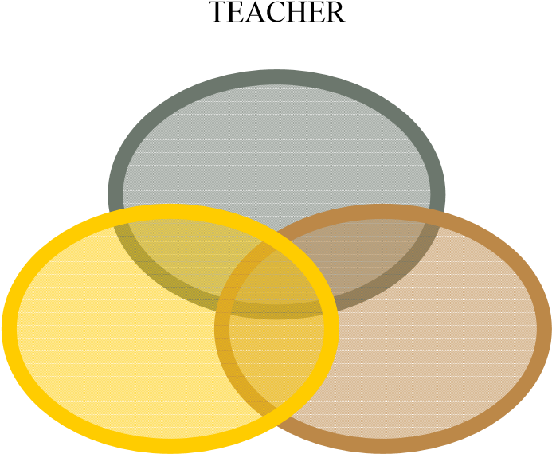 MULTIMEDIA

VARIOUS MULTIMEDIA TOOLS
Tools | METHODS | EXAMPLES | METAPHORS
Mspowerpoint, Astound  Graphics and Flash Slide  Show Software | Easy to prepare and it can be prepared with many of the popular multimedia elements like graphs, sound and video. | 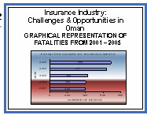 | SLIDE BASED
Macromedia, Flash Authorware, BPP I  Learn and I Pass | Presentation is created using icons to represent different media elements and placed in a flowline. |  | ICON BASED
Windows Movie Maker, Winampp, Macromedia  Director | Presentation is  created using moviemaking concepts of casts, sounds,  pictures and scores |  | MOVIE  BASED
Adobe Acrobat Reader | Easy to prepare and with word documents if u have Acrobat Reader 5 with many popular multimedia elements like graphs sound and charts | 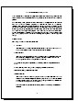 | BOOK BASED

(B)OTHER INNOVATIE TOOLS SUGGESTED
The researchers suggest some of the methods can very well be applied by the modern teachers. As the researchers feel that basically the core objective of teaching should never be deviated by the use of an innovative method. The following methods which are suggested are an extension to the traditional methods of teaching.

(1) MIND MAP
Mind maps were developed in the late 60s by Tony Buzan as a way of helping students make notes that used only key words and images, but mind map can be used by teachers to explain concepts in an innovative way. They are much quicker to make and much easier to remember and review because of their visual quality. The nonlinear nature of mind maps makes it easy to link and cross-reference different elements of the map.
Mind Maps are also very quick to review, as it is easy to refresh information in your mind just by glancing once. Mind Maps can also be effective mnemonics and remembering their shape and structure can provide the cues necessary to remember the information within it. They engage much more of the brain in the process of assimilating and connecting facts than conventional notes.
The key notion behind mind mapping is that we learn and remember more effectively by using the full range of visual and sensory tools at our disposal. Pictures, music, color, even touch and smell play a part in our learning armory will help to recollect information for long time. The key is to build up mind maps that make the most of these things building on our own creativity, thinking and cross linking between ideas that exist in our own minds.
As the recent research point that any particular information explained with the help of graph charts make a high impact in the minds of the people and keeping this as the core aspect the teachers may try to picturize the concepts and show the same to the students

Chart 4 - AN EXAMPLE OF MIND MAP FOR SCALAR QUANTITIES
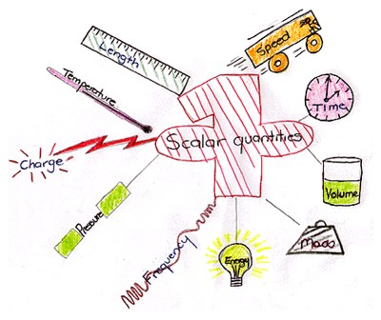

This would bring very high impact on the minds of the students about a concept
- Creates clear understanding  PowerPoint can be used widely.
- Innovative thinking improves

(2 ) TEACHING WITH SENSE OF HUMOUR – “HUMOUR AN EFFECTIVE MEDIUM OF TEACHING”
Everyone loves a teacher with an infectious sense of humor. Looking at the lighter side of life not only fosters cordial relations between professors and students, but also provides welcome relief while trying to follow a difficult lecture on a complicated subject. When there is a willingness to change, there is hope for progress in any field. Teaching is a challenge. Learning is a challenge. Combining both effectively is a challenge. Being humorous is a challenge. However, laughing is easy. We are convinced both by experience and research that using humour in teaching is a very effective tool for both the teacher and student.
Humor strengthens the relationship between student and teacher, reduces stress, makes a course more interesting and if relevant to the subject, may even enhance recall of the material. Humor has the ability to relax people, reduce tension, and thereby create an atmosphere conducive for learning and communication. Numerous studies in the field of advertising have noted that humor is the most effective tool for enhancing recall of advertisements.
It is easy to create a humor in the classroom by reading books of jokes and to listen to professional comics. The students should be encouraged to take notes, especially to learn about the professionals’ use of such techniques as exaggeration, pauses, and timing. Observe reality and exaggerate it - much humor lies in observations about real life and truthful situations. In conclusion, humor not only plays an important role in the healing process but is also very important in education.

(3) Z TO A APPROACH
This approach attempts to explain the application part of a particular concept first. The teacher should explain the application of a particular concept first and explain the effects of such applications. For example in management subject - motivation is explained in a manner that the organization get extensive benefits out of using some techniques like promotions and awards. So here the use of promotion is explained first and later students would get interest in knowing what are promotions and awards. The teacher starts explaining what is promotion and explains what motivation theory in management is.Another example we can try is that in accounting the Income statement and Balance Sheet can be explained first and later drawing their attention to double entry system of book keeping.
Strengths
- Makes a particular concept clear
- Students develop interest to know exactly the concept.
- Creates long lasting memory/correlation of a concept.
Weaknesses
  - Take quite long time for a teacher to introduce a concept
  - Initial difficulty in understanding a particular concept will be encountered.

Chart 5 - LEANING TOWER OF PISA EXPERIMENT – EXAMPLE TO Z – A
APPROACH
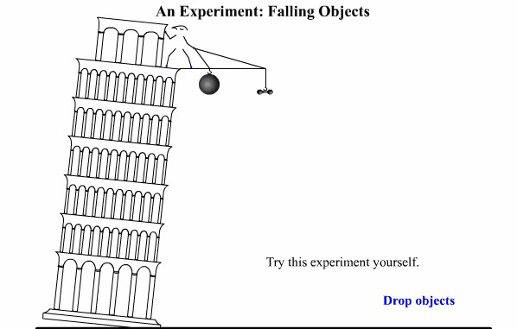

Source: vision learning
Z – A approach is explained in the following two charts. In the first chart a man drops cannonball and lead weight from the top of the building. Hypothesis for this experiment is both the object will fall at the same rate
In the second chart the cannon ball and lead weight have reached the ground.
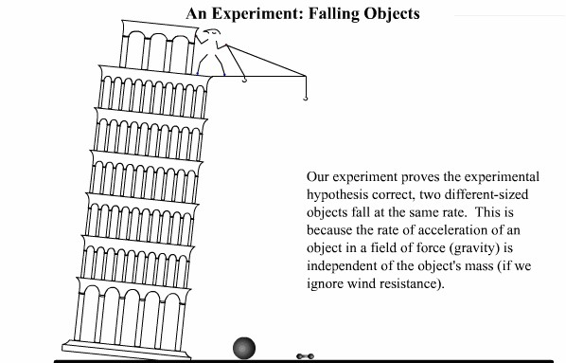

Source: vision learning
Concept Simulation - reenacts Galileo's experiment of two different objects falling at the same rate.

The above chart explains the application of that Gallileo’s theorm. Here the teacher explains how two objects reach the ground if they are put from a particular distance from ground level. Traditional way of teaching method will be explaining the theorem first and followed by its application. But this Z-A approach goes opposite in a manner that the proof or application is explained first and later the theory. Then it is explained that this the concept developed by Galileo. The above example of tower depicts a (possibly mythical) experiment in which Galileo dropped two objects from the leaning tower of pisa to demonstrate their comparable rate of descent.

(4) MNEMMONICS WORDS- WORDS –WORDS APPROACH
Here the teacher is not supposed to talk on a particular concept for a quite long time. But to make it clear to the students he can just go on saying mnemonics or its associated meaning in words. Here he goes on saying only words instead of sentence, and once they come to a basic understanding of the meaning of a particular concept then the teacher will explain in sentences. For example in teaching language courses this technique can be used as an effective medium by the teacher to develop word power.
- Dictionary must be used widely
- Word power increases
- Teacher also gets to know many words pertaining to a particular concept.

(5) ROLE PLAYING AND SCENARIO ANALYSIS BASED TEACHING
Role playing and scenario analysis is mostly used in organizations that try to analyze a problem pertaining to the organization, and this is also used in management institutions. But the similar kind of practice can be tried in other specialization too like science and engineering. Science and engineering courses have practical but in support of those practical if students are given a scenario and other options to solve a particular issue, then the students are exposed to decision making in a given environment.
For example, in teaching accounting the role of accountant can be explained by role playing technique. Invoice and bills can be given to students and asked them to assume the role of accountant. Here the real entries pertaining to transactions are made by the student and this is more practical approach to teaching where theory is supplemented by proper practical knowledge. Similar kind of technique can be applied in management, engineering and science courses.

VI.CONCLUSION
Across the world, information technology is dramatically altering the way students; faculty and staff learn and work. Internet-ready phones, handheld computers, digital cameras, and MP3 players are revolutionizing the college life. As the demand for technology continues to rise, colleges and universities are moving all sorts of student services, from laundry monitoring to snack delivery online. At Columbia University, a real-time Web-based service called Laundry View lets students log on to a Web- based system to see which washing machines are free before they head to the laundry room. They can monitor their wash and can even program the service to e-mail them when their load is done.
Technology is also changing the classroom experience. The classrooms at New York University’s Leonard N Stern School of Business feature all sorts of conveniences for students and teachers. For instance, the room is wired with cameras for photographing whiteboards, so students can receive the images as digital files. In addition, tablet PCs, compact computers that allow you to write notes directly onto the screen with a special pen, replace the archaic projector. With the tablet technology allow professors to make notes on charts and spreadsheets and send them directly to their students' PCs and he will get a feed back from each student.

From the above, we can make out that the Information and communication technology has made many innovations in the field of teaching and also made a drastic change from the old paradigm of teaching and learning. In the new paradigm of learning, the role of student is more important than teachers. The concepts of paperless and penless classroom are emerging as an alternative to the old teaching learning method. Nowadays there is democratization of knowledge an the role of the teacher is changing to that of facilitator. We need to have interactive teaching and this changing role of education is inevitable with the introduction of multimedia technology and the spawning of a technologically-savvy generation of youths.
The analysis reveals some of the suggestions that the teaching community can practice in the classrooms. Ultimately the teaching people are satisfied when he could reach the students community with his ideas and views. So, teaching depends upon successful mode of communication and Innovation though we mean the changes that we propose to be included in our medium of communication or even inclusion of some other elements in communicating information.
The researchers recommend that the teaching would be highly effective if the teacher start to use the recent multimedia technologies like usage of computers extensively or some modifications in the conventional mode of teaching. The use of computers may be very well practiced in the environment where the use of such technology is highly possible, but there must be some sort of innovation which can also be practiced in an environment where such use of technology is on its way to growth. In those environments use of humor, role playing, words –words approach, Z-A approach are the ideas that can very well be practiced.
The researchers believe that the core objective of teaching is passing on the information or knowledge to the minds of the students. Any method using computers or modifying the existing conventional chalk-talk method are innovative if they ultimately serve the attainment of core objective of teaching.

VII. Research limitations
As the weaknesses that are explained in this research work are purely the views and perceptions of the researchers and which could not be generalized. Even the modifications suggested might suffer from other limitations. The researchers try to suggest some useful modifications which could be tried by teachers as innovative to get maximum results.

REFERENCES
- Agnew, P. W., Kellerman, A. S. & Meyer, J. (1996). Multimedia in the Classroom, Boston: Allyn and Bacon.
- Boud, D. & Feletti, G. (1999). The Challenge of Problem-Based Learning, (2nd Ed.), London: Kogan Page.
- Hofstetter, F. T. (1995). Multimedia Literacy, New York: McGraw-Hill.
- Jonassen, D. H., Peck, K. L., and Wilson, B. G. (1999). Learning With
Technology: A Constructivist Perspective, New Jersey: Merrill/Prentice Hall.
- Lindstrom, R. (1994). The Business Week Guide to Multimedia Presentations: Create Dynamic Presentations That Inspire, New York: McGraw-Hill.
- Tapscott, D. (1998). Growing Up Digital: The Rise of the Net Generation, New York: McGraw-Hill.
- Teo, R. & Wong, A. (2000). Does Problem Based Learning Create A Better Student: A Refelection? Paper presented at the 2nd Asia Pacific Conference on Problem –Based Learning: Education Across Disciplines, December 4-7, 2000, Singapore.
- Vaughan, T. (1998). Multimedia: Making it Work (4th Ed.), Berkeley, CA: Osborne/McGraw-Hill
- BPP (2000), Success in your Research and Analysis Project.
- CFA Level 2 Book Edition 2000
- Dunn, Philip (2001) Interpretation of Accounts. Uk, Student Accountant January 2001

